Choose the best parameter to calculate diameter

For each vessel, if it is the first time, you need to run **diameter(animalid, dateid, run, pmt)** to catch a place and calculate the diameter. But it is likely the result is ideal when you check the output response_topo.tif. At this time, you don’t need to run diameter again as it will load the whole data again and it is really time consuming. A better way is to run **diameter_in_folder(folderpath, method).** You give the path of your bv_1 (or other bv folder) and try another algorism (method) to calculate the diameter. The output will be **method_response_topo.tif, method_plot.fig, method_result.mat**. Once you check the result is good, you can rename them and overwrite the old response_topo.tif, plot.fig, result.mat and upload them to the WorkingFolder.

The references to choose a suitable algorithem:

If your blood vessel labeling is good, and have clear edge, you just need to use default method.

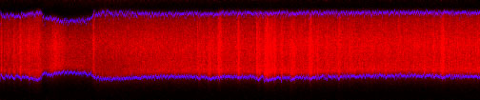

If your blood vessel is very close to another one, and it is very hard to separate them and give you a strong background, then

